**Project Planning**

**1. Project Summary**

Our project will utilize Leap Motion technology to detect unique hand gestures during a Power Point (or an open source alternative) presentation and execute associated commands, including moving to next/previous slides, skipping slides, pressing embedded buttons, and flipping between slide show mode and outline mode. This will help popularize a very promising new technology and allow for a more fluid and natural presentation. Our “reach” goals include image resizing/movement, drawing shapes onto the screen and directory browsing/presentation setup.

**2. Project Organization**

**Team Members:**

Matthew Raporte, Gregory Potter

**Client:**

Professor Huang

**Who on the team will be interfacing with client:**

Matthew Raporte, Gregory Potter

**Client meetings and status updates:**

**-Progress Reports:**

Emailed out to Professor Huang every Sunday.

**-Deliverables:**

9/29: Project Planning

10/06: Progress Report 3

10/20: Project Design

10/27: Progress Report 4

11/03: Project Implementation

11/10: Progress Report 5

11/17: V&V and Documentation

12/01: Final Posters

**-Face-to-face meetings:**

Wednesdays at 3PM, Prof. Huang’s office.

**3. Requirements:**

**Customer level requirements:**

-Easy to setup and use

-Intuitive and easy to remember commands

-Strong gesture detectability, doesn’t “miss” gestures or falsely detect gestures

-Quick detection mapping and command execution

-Robust but useful features

**Mapping to technical requirements:**

*This maps the user requirements identified in the project definition into specific technical requirements*

**Development Platform (Linux, Windows, Android,…):**

Windows because many of the APIs we want to connect to (like PowerPoint) are currently in Windows only

**Development environment / software / languages:**

C#, Java, LeapMotion SDK

**Performance requirements:**

Efficient processor usage to ensure timely command execution, good garbage collection in order not to clog up system with constant Leap Motion input. It should be able to seamlessly discard data where nothing is happening so that we aren’t constantly calculating data

**Resources required:**

Leap Motion Controller

PC/Laptop running Windows with applications like PowerPoint

**Testing methods:**

We will cycle white-box testing during development and extensive black-box testing after we have a working prototype. We will possibly utilize our product for one of our in-class presentations after sufficient testing.

**4. Project Management**

**Brief description of project execution**

We will start by researching the different APIs that we will use to get an idea of what is possible and how easy it is. From there, we will try to implement some of the simpler controls which are mostly around advancing/skipping slides, etc.

**Clear enumeration of customer requirements**

**– Identify a minimum scope you must accomplish to meet customer requirements (and pass the course)**

* Go to next, previous, and skip slides
* Play media or otherwise interact with the slide itself (highlighting perhaps)

**– Prioritize remaining tasks of the desired scope**

* Integrate with the operating system (window management)
* Operating system login screen

**Identify risk areas, and how these risks will be minimized**

The bulk of the time will be spent doing the investigation into what we can actually get done with the LeapMotion device and the PowerPoint API.

**Interfaces:**

**–** LeapMotion and the PowerPoint API

**Self-evaluation of progress**

By the end of the house, we should be able to deliver a presentation about our project using our project. Along the way we will want to keep in mind that this should be able to accomplish the productivity tasks faster or easier than with traditional keyboard or mouse. At each stage, we will need to make sure that it is performant and accurate.

**Gantt Chart**

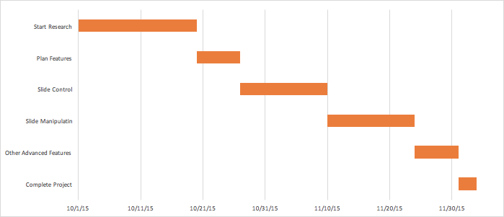

**Who will do what?**

To start, Matt will research the PowerPoint API and Greg will work with the LeapMotion programming. After the initial research phase is completed and a basic framework is present, we will likely divide the actual actions (one of us will handle advancing/skipping slides, another will work on playing media, etc)